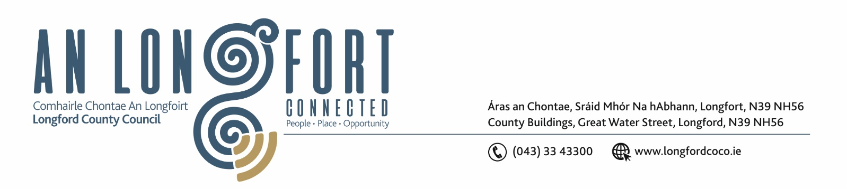

9u Eanair 2020.

Chuig: Gach Ball don Chomhairle.

A Chomhairleoir,

Iarrtar ort bheith i láthair ag Cruinniú Chomhairle Chontae Longfoirt a tionólfar i Seomra na Comhairle, Aras an Chontae, Longford ar an Chéadaoin, 15u Eanair 2020 ag 3.00 p.m chun gnó a dhéanamh d’réir an Chláir thíos.

You are requested to attend Meeting of Longford County Council to be held in the Council Chamber, Aras an Chontae, Great Water Street, Longford on Wednesday, 15th January 2020 at 3.00 p.m. to transact business, as set out on the Agenda hereunder.

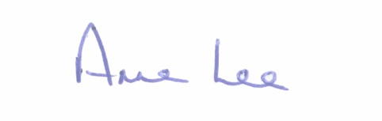
Mise le meas,

__________________
Anne Lee,
Meetings Administrator.

C L A R

Prayer before meeting.

- Confirmation of Minutes of the following meetings of Longford County Council
- Finance Committee meeting held on the 15th November 2019
- Budget Meeting held on the 25th November 2019.
- Longford County Council meeting held on the 11th December 2019.
– copies enclosed.

- Matters arising from Minutes.

3. Declaration of Interest by Members.

- To note Management Report - to follow.

- To note adopted Minutes of Corporate Policy Group Meeting held on the 13th November 2019 – enclosed.

- Community, Corporate and Enterprise.

- Strategic Policy Committee Scheme 2019 – 2024 - Sectoral Representatives.

- Consideration and adoption of Draft County Longford Heritage Plan.

(c) Political Donations - Local Elections (Disclosure of Donations
and Expenditure ) Act 1999, as amended - Members of Local Authorities.
(Guidelines and forms available at Council Meeting)

6. Finance & Regeneration.

- To Note NOAC Performance Indicators Report 2018 – enclosed.

7. Strategic Infrastructure and Climate Change.

- To note Planning Applications received since last meeting of the Council.
- Notice of Motion submitted by Councillor Gerry Warnock.
“I am seeking the support of the Members for approval in principal for a ‘New Build Affordable Housing Scheme’ that I hope can eventually be used by Longford County Council as an additional tool to provide affordable housing options for qualifying local households. If supported by the Members, I plan on submitting this scheme directly to the Minister for his observations, and perhaps seek his approval and financial support for a pilot under the Rebuilding Ireland Programme.”

8. General.
(a) Notices of Motions submitted by Councillors, as listed hereunder –
Councillor Micheal Carrigy.
“I am calling on the Department of Education to employ Occupational and Speech and Language therapists in each county to cover all schools. This would allow for Therapists to see children with needs in their learning environment which would allow them to best advise teachers on how to create a positive learning environment for children with additional needs.”
“I call on the Minister for Health to consider an extension of the free dental healthcare checks to children after they leave primary school.”
Councillor Martin Monaghan.
“That we as a Council, and with support from my fellow colleagues, recommend that we do not support the commemorations for the RIC . This is something that our ancestors would never forgive us for showing support for a force that terrified our people in their fight for freedom.”

8. Votes of sympathy.

9. Training -
Consideration of Report from Corporate Policy Group.



